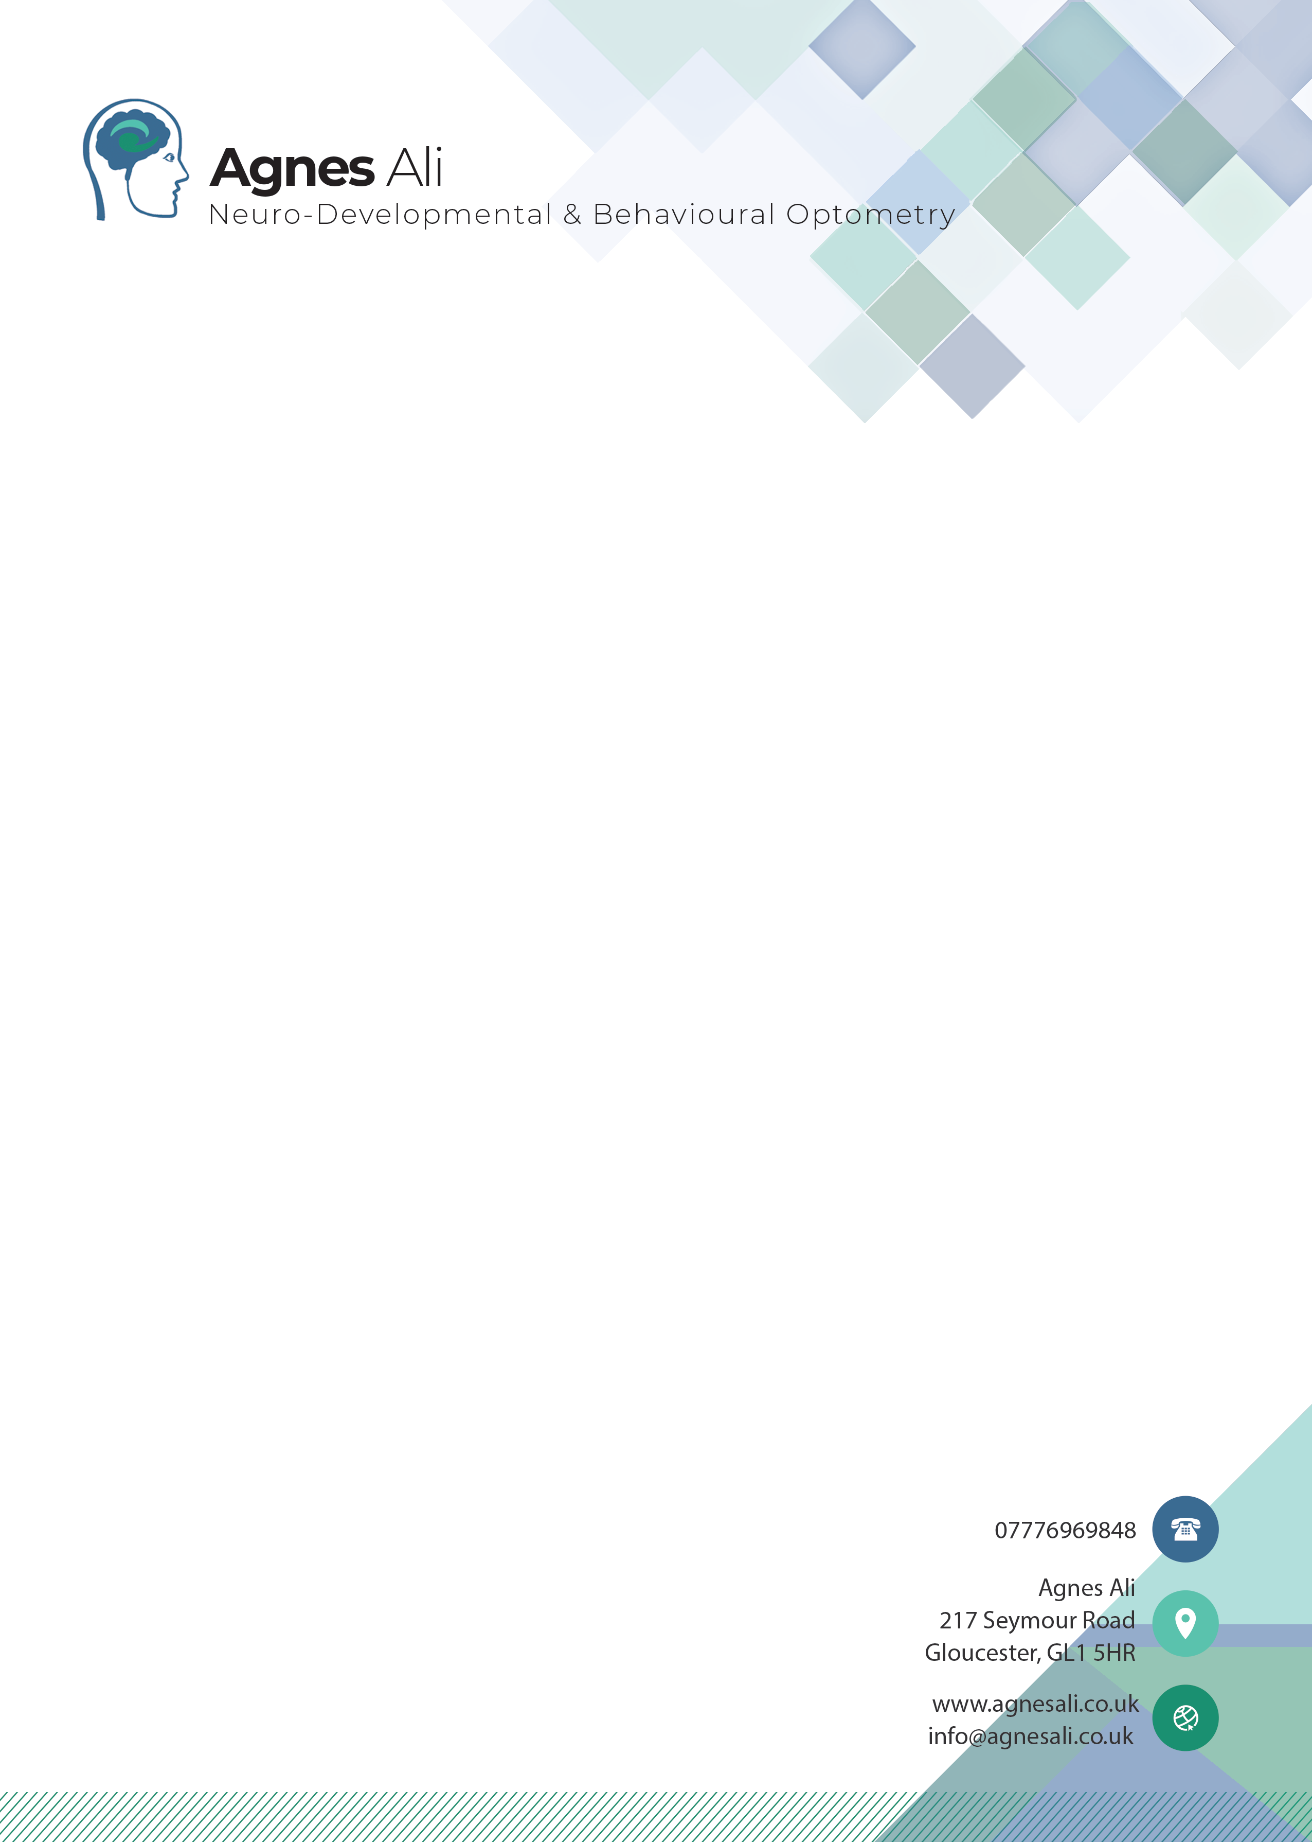

Example 2 page report:
To the parents of John
Email:

Gloucester, 16/05/2026

Dear parents of John,

Re: John D.O.B: 14/16/2010

A full Neuro-Developmental Optometry assessment was completed with John on 16/05/2026. The following areas were assessed:

Visual Acuity
John’s vision is within the normal range (6/7.6 in both eyes with minimal correction), so glasses are not needed, but he showed a consistent difficulty reading letters in the correct order on the chart.

Reading Performance & Coloured Overlay
John reads slowly and must sound out many words. A Jade coloured overlay significantly improved his reading speed: Without overlay: 28 words / 30 sec. With Jade overlay: 36 words / 30 sec. This confirms visual stress, and the overlay provides genuine relief. (Overlays can be purchased at www.crossboweducation.com)

Binocular Vision (Eye Teaming)
Significant issues were found with how John’s eyes work together. He shows a convergence insufficiency (normal <10 cm; John 15–30 cm) His eyes drift outward (exophoria) and I noted poor stamina for maintaining single, stable vision. He had unstable depth perception (100–400 seconds of arc).

Eye Focusing (Accommodation)
John has normal focus range in the right eye but weak focusing ability in the left eye. He will experience difficulty switching focus between near and far and trouble maintaining clear near vision.

Eye movement skills
John has full eye muscle movement but significant difficulties with accuracy of fixation, tracking, and saccadic eye movements—often using head movements to compensate. This is reflected in very poor Developmental Eye Movement test performance, indicating reduced oculomotor control affecting reading tasks.

Visual Perceptual Skills
John shows significant difficulties with visual directionality (<1st percentile), weak visual-motor integration (5th percentile), and reduced visual sequential memory, despite strong visual discrimination skills, which may impact reading, spelling, and accuracy in school tasks.

Primitive & Postural Reflexes
John shows retained ATNR and STNR primitive reflexes, which may be impacting his motor development, posture, coordination, eye movements, attention, and ability to perform tasks such as reading, writing, and copying efficiently.

Balance & Bilateral Integration
John shows difficulties with body coordination and bilateral integration, requiring significant effort and conscious control to perform tasks involving both sides of the body. This may impact motor skills, processing speed, and higher-level tasks such as learning, problem-solving, and emotional regulation.

Overall Findings
John has a cluster of visual, motor, and perceptual difficulties that directly affect his reading ability. His challenges stem from: poor eye teaming, weak focusing, impaired tracking, mild reflex retention and bilateral integration difficulties. All of these create visual confusion, and can be reason for fatigue, slow processing, reduced comprehension, and avoidance of reading.
However, all identified issues are treatable, and John is an excellent candidate for improvement through vision therapy.

Recommended Treatment Plan
A structured 6–9 month Vision Therapy program targeting: convergence, accommodation, eye movements, bilateral integration and reflex inhibition. Therapy will be delivered through home exercises (about 10 minutes daily, ideally 7 days/week) and in-person reviews every 2 months. Improvements can be seen as early as 4–8 weeks into the programme. Strong outcomes depend on consistent daily repetition with all exercises.

Recommendations for School
- Seat John directly facing the board, not at an angle.
- Provide text with good spacing, ideally double-spaced.
- Use of a jade coloured overlay should be encouraged.
- Jade coloured notebooks will likely improve quality of writing
- Worksheets and exams should be printed on Jade coloured paper.
- Avoid cramped worksheets; use dyslexia-friendly formats.
- Consider a dyslexia-friendly dictionary (e.g., Barrington Stoke). Can be found at www.booksforbugs.co.uk
- The family is recommended to prioritise vision therapy exercises over school homework for the next 6-9 months.

If you need any further information and explanation, please contact me at the above address.
Yours sincerely,
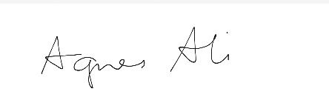
Agnes Ali
BSC (Hons) Optometry, MBABO, GOC-01-24746

